**PART II: CHEMISTRY**

**SECTION 1 (Maximum Marks: 24)**

This section contains **SIX (06)** questions.

Each question has **FOUR** options for correct answer(s). **ONE OR MORE THAN ONE** of these four option(s) is (are) correct option(s).

For each question, choose the correct option(s) to answer the question.

Answer to each question will be evaluated according to the following marking scheme:

*Full Marks* : **+4** If only (all) the correct option(s) is (are) chosen.

*Partial Marks* : **+3** If all the four options are correct but ONLY three options are chosen.

*Partial Marks* : **+2** If three or more options are correct but ONLY two options are chosen, both of

which are correct options.

*Partial Marks* **: +1** If two or more options are correct but ONLY one option is chosen and it is a

correct option.

*Zero Marks* : **0** If none of the options is chosen (i.e. the question is unanswered).

*Negative Marks* : **-2** In all other cases.

**For Example:** If first, third and fourth are the ONLY three correct options for a question with second option being an incorrect option; selecting only all the three correct options will result in +4 marks. Selecting only two of the three correct options (e.g. the first and fourth options), without selecting any incorrect option (second option in this case), will result in +2 marks. Selecting only one of the three correct options (either first or third or fourth option) ,without selecting any incorrect option (second option in this case), will result in +1 marks. Selecting any incorrect option(s) (second option in this case), with or without selection of any correct option(s) will result in -2 marks.

Q.1 The compound(s) which generate(s) N2 gas upon thermal decomposition below 300°C is (are)

(A) NH4NO3 (B) (NH4)2Cr2O7

(C) Ba(N3)2 (D) Mg3N2

***Sol.* B, C**

1. NH4NO3 ——>N2O + 2H2O (N2O can further decompose to N2 and O2 at temperature above 300oC)
2. (NH4)2 Cr2O7 ——>N + Cr2O3 + 4H2O
3. Ba (N3 )2 '> 3N2 + Ba
4. Mg3N2 does not decompose at any temperature.

Q.2 The correct statement(s) regarding the binary transition metal carbonyl compounds is (are)

(Atomic numbers: Fe = 26, Ni = 28)

1. Total number of valence shell electrons at metal centre in Fe(CO)5 or Ni(CO)4 is 16
2. These are predominantly low spin in nature
3. Metal–carbon bond strengthens when the oxidation state of the metal is lowered
4. The carbonyl C-O bond weakens when the oxidation state of the metal is increased

***Sol.* B, C**

1. Electronic configuration of central metal atom in both cases is [Ar] 3d104s24p6 (8 electrons in outermost shell and 18 valence electrons respectively).
2. Low spin complex because CO is a strong field ligand.
3. Metal-carbon bond strengthens when the oxidation state of metal is lowered.
4. The carbonyl C – O bond becomes stronger when the oxidation state is increased.

Q.3 B ased on the compounds of group 15 elements, the correct statement(s) is (are)

1. Bi2O5 is more basic than N2O5
2. NF3 is more covalent than BiF3
3. PH3 boils at lower temperature than NH3
4. The N-N single bond is stronger than the P-P single bond

***Sol.* A, B, C**

Bi2O5 is more basic than N2O5.

NF3 is more covalent than BiF3.

PH3 boils at lower temperature than NH3.

N – N single bond is weaker than P – P single bond.

Q.4 In the following reaction sequence, the correct structure(s) of X is (are)

1. PBr3, Et2O

X

1. Nai, Me2CO
2. 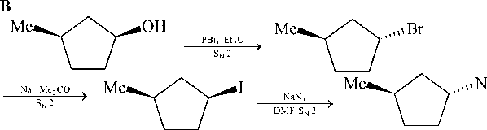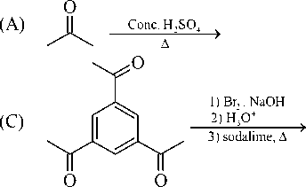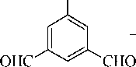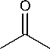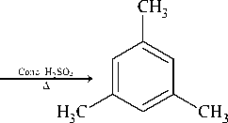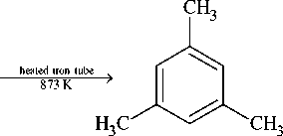NaN3 , HCONMe2

Me

N3

enantiomerically pure

(A)

***Sol.***

Q.5

The reaction(s) leading to the formation of 1,3,5-trimethylbenzene is(are)

(B) Me

**H**heated iron tube

873 K

->

(D)

CHO

Zn/Hg, HCl

■»

***Sol.* A, B, D**

(1,3,5 - trimethylbenzene)

CH3 - C = C - H

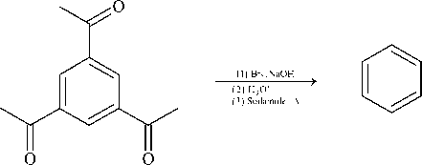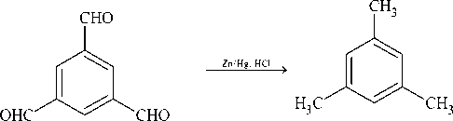* Q.6 A reversible cyclic process for an ideal gas is shown below. Here, *P*, *V*, and *T* are pressure, volume and temperature, respectively. The thermodynamic parameters *q*, *w*, *H* and *U* are heat, work, enthalpy and internal energy, respectively.

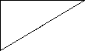<D E 3

A(P1,V1,T1) C(P2, V1, T2)

B(P2,V2,T1)

Temperature (T)

The correct option(s) is (are)

1. qAC = AUBC and wAB = P2(V2 V1)

(C) AHCA < AUCA and qAC = AUBC

1. Wbc = P2(V2—Vi) and qBc = AHac

(D) qBc = AHac and AHca > AUca

***Sol.* B, C**

AHac +AHcb +AHba = 0

AHba = 0 (Temperature is constant)

AHac = AHbc ... (1)

We know that qP = AH (In path Bc, P = constant)

Hence qBc = AHBc

From Eq. (1)

qBc = AHAc

(B) Qbc = -P2 (V, - V2 ) = P2 (V2 - V,)

(c) AHca = ncp (T - T2) = -ncp (T2 - T)

AUca = ncV (T1 - T2 ) =-ncV (T2 - T1)

As, CP > CV

So, AHca < AUca

**SECTION 2 (Maximum Marks: 24)**

* This section contains **EIGHT (08)** questions. The answer to each question is a **NUMERICAL VALUE.**
* For each question, enter the correct numerical value (in decimal notation, truncated/rounded-off to the

**second decimal place**; e.g. 6.25, 7.00, –0.33, –.30, 30.27, –127.30) using the mouse and the on-screen virtual numeric keypad in the place designated to enter the answer.

* Answer to each question will be evaluated according to the following marking scheme:

*Full Marks* : **+3** If ONLY the correct numerical value is entered as answer.

*Zero Marks* : **0** In all other cases.

Q.7 Among the species given below, the total number of diamagnetic species is ___. H atom, NO2 monomer, O2- (superoxide), dimeric sulphur in vapour phase, Mn3O4, (NH4)2[FeCl4], (NH4)2[NiCl4], K2MnO4, K2CrO4

***Sol.* 1**

Paramagnetic: H, NO2 monomer O- (superoxide), S2 (Vapour), [Mn3O4 is mixed oxide of Mn+2 and Mn+3], (NH4)2 [FeCl4], (NH4)2[NiCl4], K2MnO4

Diamagnetic: K2CrO4

Q.8 The ammonia prepared by treating ammonium sulphate with calcium hydroxide is completely used by NiCl2.6H2O to form a stable coordination compound. Assume that both the reactions are 100% complete. If 1584 g of ammonium sulphate and 952 g of NiCl2.6H2O are used in the preparation, the combined weight (in grams) of gypsum and the nickel-ammonia coordination compound thus produced is .

(Atomic weights in g mol–1 : H = 1, N = 14, O = 16, S = 32, Cl = 35.5, Ca = 40, Ni = 59)

***Sol.* 2992**

Ca (OH )2 +(NH4 )2 SO4 moles 12 1584 = 12

*■ 2NH3 + CaSO4.2H2O (Gypsum)

24 12

132

Weight of gypsum formed = 12 × 172 = 2064 g

NiCl2.6H2O + 6NH3 > [ Ni (NH3 )6 ] Cl2

moles 952 24

=4 —=4

238 6

Mass of [Ni(NH3)6] Cl2 formed = 4 × 232 = 928 g Total weight = 2064 + 928 = 2992 g.

Q.9 Consider an ionic solid **MX** with NaCl structure. Construct a new structure (**Z**) whose unit cell is constructed from the unit cell of **MX** following the sequential instructions given below. Neglect the charge balance.

1. Remove all the anions (**X**) except the central one
2. Replace all the face centered cations (**M**) by anions (**X**)
3. Remove all the corner cations **(M)**
4. Replace the central anion (**X**) with cation (**M**)

„ ( number of anions ) . „ .

The value of I I in **Z** is .

( number of cations J

***Sol.* 3**

X - = Octahedral void

M+ = FCC point

M+ X-

1. 4 4 – 3 = 1
2. 4 - 6 x - 1 + 6 x -

22

1. 1 – 1 3 + 1 = 4
2. 0 + 1 4 – 1 = 3

Hence anion = 3 = 3 cation 1

F or the electrochemical cell,

Q.10

Mg(s) | Mg2+ (aq, 1 M) || Cu2+ (aq, 1 M) | Cu(s)

the standard emf of the cell is 2.70 V at 300 K. When the concentration of Mg2+ is changed to ***x*** M, the cell potential changes to 2.67 V at 300 K. The value of ***x*** is .

(given, F = 11500 K V-1, where *F* is the Faraday constant and *R* is the gas constant, ln(10) = 2.30)

R

**10**

***Sol.***

Case I:

EceU = EOe! I- “ cell cell

2F 1

= 2.7 – 0 = 2.7 V Case II:

0

cell cell

-

RT x

**/**n —

2F 1

2.67 = 2.7

R x 300

2F

**/**nx

-0.03

R x 300

2F

**/**nx

**/**nx =

0.03 x 2 x F

300 x R

= 2.3

x = 10

* Q.11 A closed tank has two compartments **A** and **B**, both filled with oxygen (assumed to be ideal gas). The partition separating the two compartments is fixed and is a perfect heat insulator (Figure 1). If the old partition is replaced by a new partition which can slide and conduct heat but does **NOT** allow the gas to leak across (Figure 2), the volume (in m3) of the compartment **A** after the system attains equilibrium is

.

**1 m3, 5 bar,  
400 K  
A**

**3 m3, 1 bar, 300 K  
B**

**Figure 1**

**A**

**B**

**Figure 2**

***Sol.***

**2.22**

As in fig 2, the system attains equilibrium, so,

PA = PB and TA = TB

PaVa = PbVb

RnATA nBTBR

Va = nA

VB nB

nA =

5

400 R

nB

3  
300R

Due to sliding of piston vol. of A will be increased by x and that of B will be decreased by x.

VA = 1 + x

VB = 3 – x

5

1 + x = 400R

3 - x 3

300R

4 (1 + x) = 5 (3 - x)

4x + 5x = 11 ^ x = —

9

Hence volume of container A will be

VA = 1 +11 =

A9

20

9

= 2.22

Q.12 Liquids **A** and **B** form ideal solution over the entire range of composition. At temperature **T**, equimolar binary solution of liquids **A** and **B** has vapour pressure 45 Torr. At the same temperature, a new solution of **A** and **B** having mole fractions *x*A and *x*B, respectively, has vapour pressure of 22.5 Torr. The value of *x*A/*x*B in the new solution is .

(given that the vapour pressure of pure liquid **A** is 20 Torr at temperature T)

***Sol.***

**19**

11

x a = —, x„ = —

A2B2

P = P“1 + P°x -

T A2 B 2

(Given PA = 20 )

90 = 45 x 2 = PA0 + P" (1)

AB

P" = 90 - 20 = 70

B

22.5 = PAxa + PB0(1 - xA)

= 20xa + 70 (1 - xa )

22.5 = 20xA + 70 - 70xA = 70 - 50xA

xA

xB

47.5 = 19

50 20

1

20

19

xA 20

=T

20

= 19

* Q.13 The solubility of a salt of weak acid (**AB**) at pH 3 is **Y** × 10–3 mol L-1. The value of **Y** is .

(Given that the value of solubility product of **AB** (Ksp) = 2 × 10–10 and the value of ionization constant of **HB** (Ka) = 1 × 10–8)

***Sol.***

**4.47**

AB **^=±** A++ B-

S (S-x)

2 x10-10 = S (S - x)

… (1)

B- + H+ **; ^** HB

(S-x) 10-3 x

1. = x

10-8 = (S - x )x10-3

— = 105 S - x

… (2)

Multiply equation (1) and (2).

S.x = 2 × 10-5

From Eq. (1)

S2 - Sx = 2 x1Q-10

S2 - 2 x1Q-5 = 2 x1Q-1q

S2 = 2 x1Q-5 + 2 x1Q-10 = 2 x1Q-5

S = 4.47 × 10-3

y = 4.47

Q.14

The plot given below shows P—T curves (where *P* is the pressure and *T* is the temperature) for two solvents **X** and **Y** and isomolal solutions of NaCl in these solvents. NaCl completely dissociates in both the solvents.

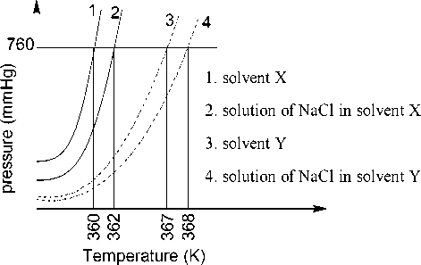

***Sol.***

2S **===** S2

a

1-a 2

On addition of equal number of moles of a non-volatile solute **S** in equal amount (in kg) of these solvents, the elevation of boiling point of solvent **X** is three times that of solvent **Y**. Solute **S** is known to undergo dimerization in these solvents. If the degree of dimerization is 0.7 in solvent **Y**, the degree of dimerization in solvent **X** is .

**0.05**

1. = 2 X Kb(x)m
2. = 2Kb( y) m

Kb(x) = 2

K

b(y)

AT, . =11 -a |K., ,m

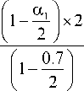b(x) I 2 J b(x)

AT =

b( y)

1

-

a 2

2

Km

b( y)

a

i = 1 - a +—

2

3 =

AT( b(x) =

1

—

a1

2

K b(x)

i = 1 -

a

2

—

0.7

2

K

b( y)

AT, , b( y)

a ) 3 X 0.65

1 1 = = 1.5 x 0.65

1. *)* 2

a1 = 0.05

**SECTION 3 (Maximum Marks: 12)**

This section contains **TWO (02)** paragraphs. Based on each paragraph, there are **TWO (02)** questions.

Each question has **FOUR** options. **ONLY ONE** of these four options corresponds to the correct answer.

For each question, choose the option corresponding to the correct answer.

Answer to each question will be evaluated according to the following marking scheme:

*Full Marks* : **+3** If ONLY the correct option is chosen.

*Zero Marks* : **0** If none of the options is chosen (i.e. the question is unanswered).

*Negative Marks* : **-1** In all other cases.

**PARAGRAPH “X”**

Treatment of benzene with CO/HCl in the presence of anhydrous AlCl3/CuCl followed by reaction with Ac2O/NaOAc gives compound **X** as the major product. Compound **X** upon reaction with Br2/Na2CO3, followed by heating at 473 K with moist KOH furnishes **Y** as the major product. Reaction of **X** with H2/Pd-C, followed by H3PO4 treatment gives **Z** as the major product.

**(*There are two questions based on PARAGRAPH* “X”*, the question given below is one of them*)**

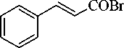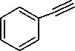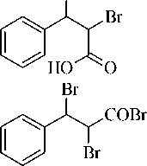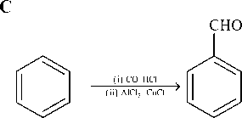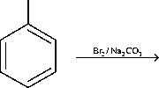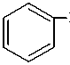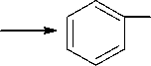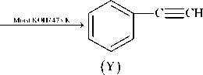

Q.15 The compound Y is

(A)

OH

***Sol.***

(C)

(B)

(D)

AC2O/NaOAc

HC CH COOH

(X)

Br+

CH

**PARAGRAPH “X”**

Treatment of benzene with CO/HCl in the presence of anhydrous AlCl3/CuCl followed by reaction with Ac2O/NaOAc gives compound **X** as the major product. Compound **X** upon reaction with Br2/Na2CO3, followed by heating at 473 K with moist KOH furnishes **Y** as the major product. Reaction of **X** with H2/Pd-C, followed by H3PO4 treatment gives **Z** as the major product.

***(There are two questions based on PARAGRAPH “X”, the question given below is one of them)***

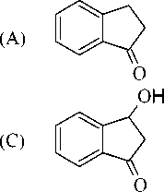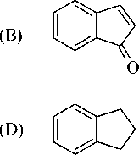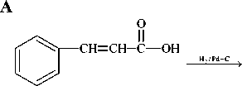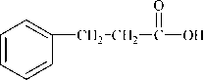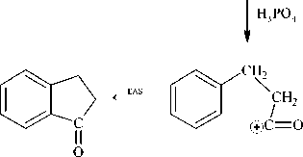

Q.16

The compound Z is

***Sol.***

1. H2/Pd-C
2. NH3/A
3. Br2/NaOH

S< 4)CHCl3,KOH,A  
5)H2/Pd-C

P

**PARAGRAPH “A”**

An organic acid **P** (C11H12O2) can easily be oxidized to a dibasic acid which reacts with ethylene glycol to produce a polymer dacron. Upon ozonolysis, **P** gives an aliphatic ketone as one of the products. **P** undergoes the following reaction sequences to furnish **R** *via* **Q**. The compound **P** also undergoes another set of reactions to produce **S**.

1)H2/Pd-C 1)HCl

1. SOCl2 2) Mg/Et2O
2. MeMgBr, CdCl2 > Q 3)CO2(dry ice)
3. NaBH4 4) H3O+

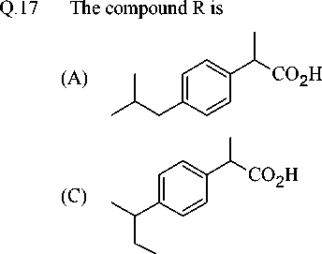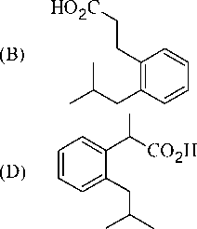***(There are two questions based on PARAGRAH ‘A’, the question given below is one of them)***

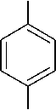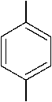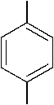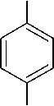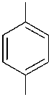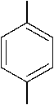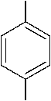**PARAGRAPH “A”**

***Sol.***

**A**

COOH

CH

COOH

CH2

COCl

CH2

C

H C CH

3 [P] 3

CH

H3C CH3

CH

H3C CH3

MeMgBr / CdCl2

MgCl

Me C H

CH2

CH

OH

Me C H

CH2

CH

H3C CH3

COMe

CH2

H3C

CH3

CH

H3C CH3

CO2/H3O+

[Q]

COOH

Me C H

CH2

CH

H3C [Rf"CH3

An organic acid **P** (C11H12O2) can easily be oxidized to a dibasic acid which reacts with ethylene glycol to produce a polymer dacron. Upon ozonolysis, **P** gives an aliphatic ketone as one of the products. **P** undergoes the following reaction sequences to furnish **R** *via* **Q**. The compound **P** also undergoes another set of reactions to produce **S**.

1)H2/Pd-C 1)HCl

1. H2/Pd-C
2. NH3/A
3. Br2/NaOH

S< 4)CHCl3,KOH,A  
5)H2/Pd-C

P

1. SOCl2 2) Mg/Et2O
2. MeMgBr, CdCl2 > Q 3)CO2(dry ice)
3. NaBH4 4) H3O+

***(There are two questions based on PARAGRAPH “A”, the question given below is one of them)***

Q.18

The compound S is

(A)

(C)

(B)

(D)

***Sol.***

**B**

(i) H2/Pd-C (ii)NH3,A

CHCl3,KOH, A

[S]

